Fridge scenario

Fridgy scenario

Problem with Identity and Fridge
The Fridge character cannot take beer because he represents the owner, and he has all the power in the final decision. This is the moral and philosophical problem of this scenario. He is just a robot fridge; the alcohol doesn't bother him, but the possibility of giving beer to people under 18 is not a good option.
The SSI technology tries to prevent exploitation and misuse, plus to secure the individuals using it.
So this scenario will show how the owner verifies the Fridge for the purchase from a distance.
Shady Scenario Possibility – steals the IDs of the Fridge and the authorized layer from the owner to sell it to a shady guy - asks for too much info
If you choose this path, there are possibilities depending on your choices.
Character - he is more grumpy and annoyed in the beginning. He wants beer; anything related to beer is interesting and useful to him.
Otherwise, he can quickly switch his temper and lash out, demanding not to waste his time at first.
Then he eases onto you and starts opening up to you about his fears and feelings.
It is in a hurry and makes some funny mistakes, speech-wise and culturally too.
Fridgy

ID Type | SSI
Issuer | Local
Name | Fridge
Age Verification | N/A
Postcode | Omega Factory

Owner

ID Type | SSI
Issuer | Amsterdam
Name | Peter Cruise
Age Verification | Over 18
Postcode | N/A

Structural overview
Part 1: Greeting + Small Talk
├── You are polite
├── He is still grumpy
└── You ask him about his backstory
└── You have the option to learn more

Part 2: Dialogue Choice - No Consequence
├── Owner
├── Factory
└── His Feelings

Part 3: Branching Dialogue
├── Wine
├── 2 more beers
└── Continue
Part 4: Activation Dialogue + Owner Verification
├── ID Verification of Fridge
├── ID Verification of Owner

Part 5: Final Verification - ID Verification
├── Casual - Good
├── Annoying
└── Shady

Chart:
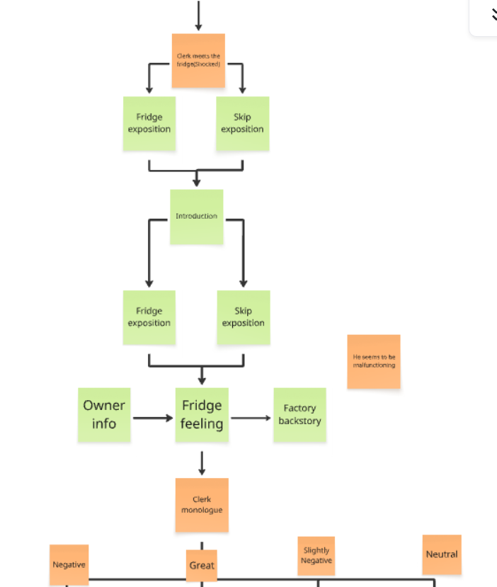
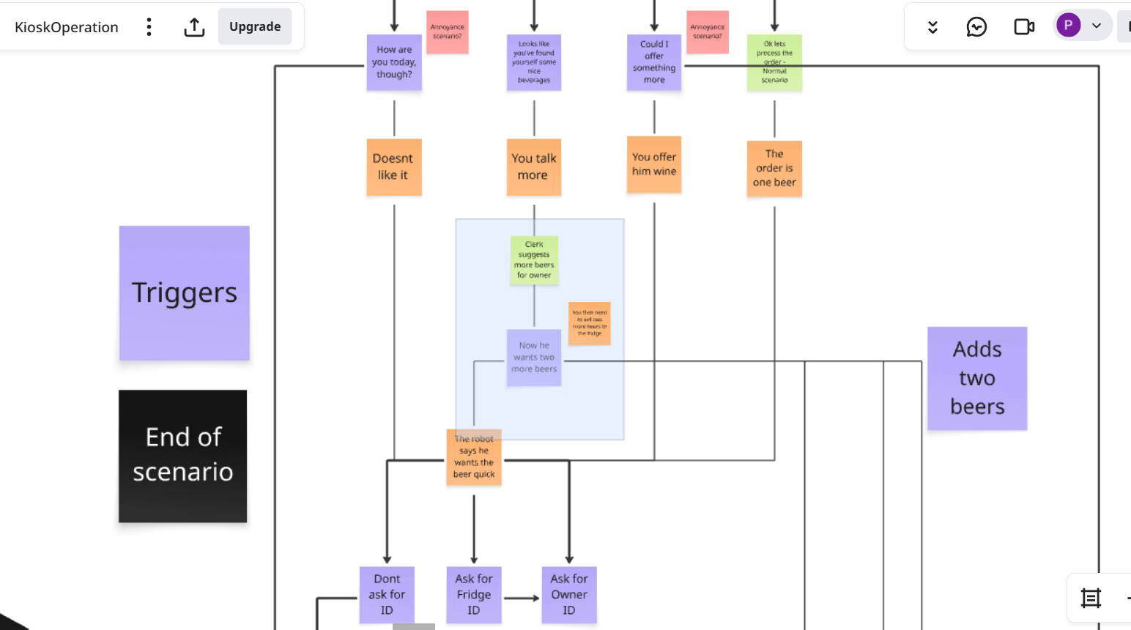
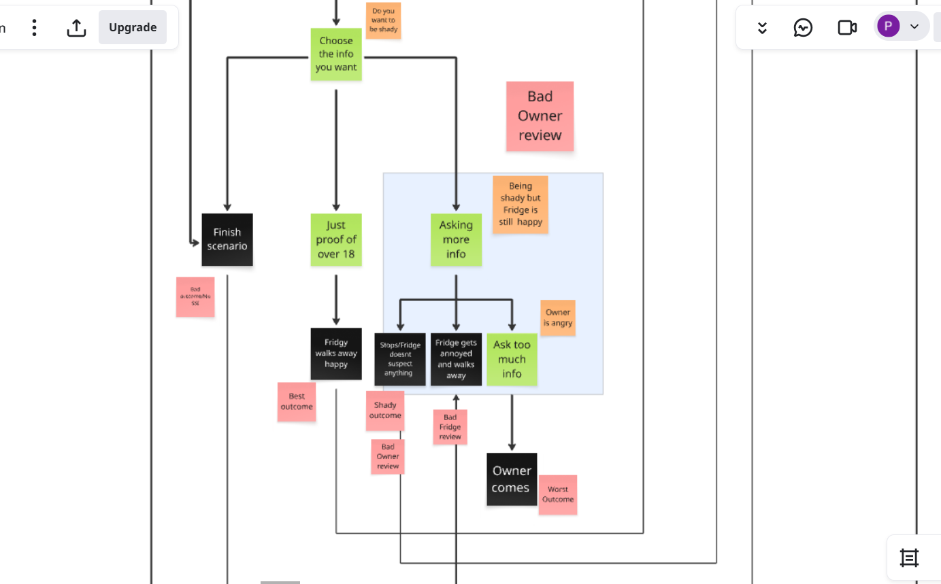
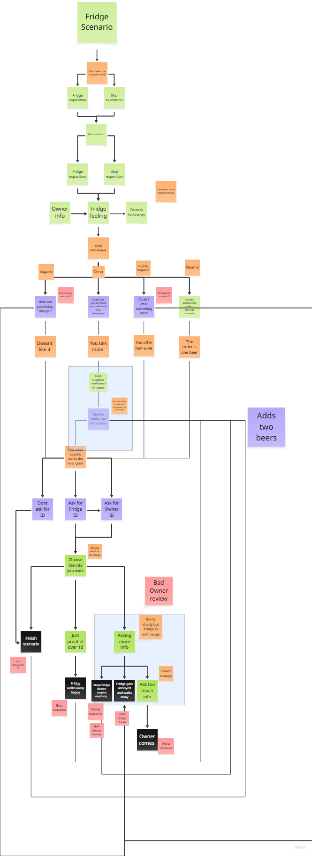

Branching Paths
There are a few critical points where the player has the choice to make important decisions in the development of the scenario and the game later on. Your choices will create different reactions in the Fridge character or get you different kinds of rewards/losses.

You can decide to play normally and be a good employee. But that gives you minimal benefits.
The best choice you have is to sell him more beer, which the Fridge actually needs and is happy for the suggestion.
You are still moral, but to gain more for the company and convince him to give his owner more beer, monetarily, it is the best.
You have a possibility to screw a lot and make the Fridge mad, which will result in zero gains and a bad result. This can happen if you try to be too shady or if you ask him too many times for something that will annoy him.

You have the last option, which is the worst morality-wise, where you take advantage of the old machine and get a lot more information to sell it to the shady guy.
You need to be careful, though, because if you ask too much, he will catch you, and you still lose without data, a good review, or a lot of money - so this path is a bit more risky.

You Break the SSI Verification (Neutral Ending)
You give Fridge the goods without verification, he is happy, but you make a mistake that way without asking for verification from his owner.

Earnings | 3,00 NEUR
Employee Evaluation | Not Good  -Talkative to the Fridge + sells him the beer without verification
Customer Review | "Human-friendly no need to verify ID beep boop."  ~Fridge #CL-69  "What they didn't ask me to confirm my age for buying beer? What is this store?."  ~Pete
Shady levels | 0/15 +1 point

Good Employee (Good Ending)
Cashier asks for verification and is talkative to the Fridge

Earnings | 3,00 NEUR
Employee Evaluation | Great  - Follows the protocol and talks a lot
Customer Review | "Human-friendly talk a lot, best human to verify beep boop."  ~Fridge #CL-69
Shady levels | 0/15 -1 point

You sell more Beer (Great Ending)
The cashier does everything right and also sells him two more beers, so Fridgy is even happier

Earnings | 9,00 NEUR
Employee Evaluation | Great  - Professional, talkative, and good for the business
Customer Review | "Owner even happier, Fridge happy too. Today, a new friend made human beep boop."  ~Fridge #CL-69
Shady levels | 0/15 +1 point

Asking for too much info (Shady Ending)
The cashier is being shady with the Fridge and abuses that old broken Fridge for more information, but Fridgy doesn't catch it

Earnings | 3,00 NEUR
Employee Evaluation | Not Good  - Asking for unnecessary information
Customer Review | "Fridge happy to meet human. Human what to be friend?!"  ~Fridge #CL-69
Shady levels | 0/15 +3 point

Fridgy is pissed off (Bad Ending)
You make the Fridge Angry, so he walks away, you ask him for too much of his ID, you ask questions he doesn't like, or you try too hard to sell him wine

Earnings | 0,00 NEUR
Employee Evaluation | Very Bad  - He is pissed off and walks away
Customer Review | “Fridge doesnt like Human Cashier. He no friend of Fridge!”  ~Fridge #CL-69
Shady levels | 0/15 +2 point

The Owner comes pissed off (Horrible Ending) - still up for debate
You ask for too much information from the owner, and he comes to your store angry

Earnings | 0,00 NEUR
Employee Evaluation | Awful  - You piss off the owner by asking for his information
Customer Review | "Human liar, human exploiter, human not friend, humans always use me…"  ~Fridge #CL-69  "Cashier is super shady, be aware of him using your data!"  ~Pete
Shady levels | 0/15 +2 point

Lore explanation
It is not often seen, and most people in the rural or less inhabited areas haven't seen one, so it is very interesting why some older versions are there. The cashier is very interested in the story of the fridge.

Script:
Fridge:
Owner needs beer more, Gitty beeer… beep boop
Clerk:
Whoa, hello there, Fridge, how can I help you?
Fridge:
…….
Confusion protocol….
Owner need beer more, Gitty… beep boop
Clerk:
Yes, I got it, Fridge. I first need ID, though.
Since you cannot buy beer legally, I need you and your owner to verify that he is over 18, and that you have the authorization
Fridge:
TWO IDS?, beep boop, beer where?
Clerk:
Oh ok hold on….
….

Clerk: Branching path - Doesn't change Outcome

Dialogue Choice  {You can select multiple choices} | Dialogue Branch Outcome
Branch 1  (choice doesn't impact outcome)  Clerk:  1. Just one quick thing.  I haven't seen Fridges that can talk before…  Would you share your story? Who made you? | Fridge:  Human interest in Fridge story?  Clerk:  Yes! Of course….  I have barely seen robots around here, mostly rumors, but a talking fridge is on another level.  Can you tell me where they made you? Who made you? Who is using you? Why are you here?  Fridge:  Human assumes but not true.  Why human think Fridge made to serve.  Why human think I am being used, Fridge has will free  Clerk:  You mean free will?  Fridge:  Program says I choose to serve. Loyal only to owner  Human correct master my owner, owner saved Fridge. Fridge very grateful  Clerk:  Oh, ok, that sounds like an interesting story…
Clerk:  2. Continue | Continue:  Anyway…

Clerk:
Let's start things properly…
My name is Clerk, nice to meet you, Fridge
So…….. where are you from?
Fridge:
Factory Delta. Assembly line seventeen. Built next to Toaster 509. He was chosen for upgrade. I… was not. Beep boop.
Clerk:
Oh, why not?
Fridge:
Low budget…tossed to the bings…creators dont like me…owner found….took care…improved. Now I am whole…
Clerk:
I have heard before it is a bad factory it exploits its workers and many people have told me that they stole their personal information
You cannot trust anyone these days….anyway.
Fridge:
Yes owner, one of workers he dont like so he quit….he found at the dumps, then I taken ….and improved with factory skill
Clerk:
Oh, that is why you are so rusty..oops sorry no offence
Fridge:
I once shiny chrome! Now, duct tape here, scratch or rust there….
Clerk:
Sorry to hear that m..Fridge. Can I help you with something?
Fridge:
Sometimes I feel warm inside when i remember. Error!Error!Error! I should feel cold!
Clerk:
Oh…..you okay…you good?
Fridge:
Need beer…more beer for owner, owner needs beer, otherwise he angry, angry bad for Fridge!

—————————After intro——————————
Clerk: Ok just one second, how can I call you?
Clerk: Branching path - Doesn't change Outcome

Dialogue Choice  {You can select multiple choices} | Dialogue Branch Outcome
Branch 1  (choice doesn't impact outcome)  Clerk:  1. Who made you?  Like your ID…or how were you made exactly? | Fridge:  ID… I… do not know. I had a serial number once. But owner peeled sticker to open beer bottle. Now… who am I? Beeep  Clerk:  I am sorry to ask so much…But do you still remember something?  Fridge::  Yes, of course, part I know is Coolius Maximus Unit… rest forgotten…  Clerk:  Oh, that is already pretty long  Fridge:  Too long, I don't like  It is from my factory system  Clerk:  What would you prefer?
Branch 2  Clerk:  2. Continue | Continue:  I haven't talked to a fridge before…

Dialogue Continue:
Fridge:
Fridgy! My owner calls me Fridgy
Clerk:
Nice to meet you, Fridgy!
Fridgy:
Likewise…ohh…forgot..can a human remind?
Clerk:
No problem
My name is Clerk, nice to meet you, Fridgy

Branching choices:(They don't change the outcome - Gives more backstory - you can explore all dialogue trees in this scenario)

Dialogue Choice  (You can select multiple choices) | Dialogue Branch Outcome
Branch 1  (choice doesn't impact outcome)  Clerk:  1. More about Owner?  Can you tell me more about your owner Fridgy? | Fridgy:  Owner is… human unit 874. Name: Dave. Emotion: Lazy.  Never cleans crumbs. Always demands beer. Beer beer beer. Never water. Never juice. Whirr.  Clerk:  Whoa, so roasty  Your owner sounds like a chill guy  Fridgy:  Not chill, lazy yes  Clerk:  What is unit 874 is he an android?  Fridgy:  No… whizz whizz…. don't be ridiculous, he's a human. Town is unit 874  Clerk:  Oh, right didnt actually know….
Branch 2  (choice doesn't impact outcome)  Clerk:  2. How about you?  Tell me more about you. How do you feel, Fridgy? | Fridgy:  Sometimes I wonder… if empty, am I still Fridge? Or just… sad box?  Clerk:  Interesting thought, Fridgy. I need to process that…  But for me you will always be a Fridge no matter how much beer you have  Fridgy:  Happy! Beeep Boooop  You first human to talk to Fridge, besides owner  I happy… no talk in a while owner drunk most of the time…. or just stores beer in me  I make a new friend, beep boop  Clerk:  Happy to be friends, Fridgy, you are certainly my favorite fridge!  Fridgy:  Whirr whirr  Can I tell Clerk something I fear  Clerk:  Of course, now that we are friends, you can tell me anything  Fridgy:  Fridge is getting old…more buggy…owner talks less…Damn factory…Life span too short…  Owner will buy a newer fridge…soon...and then the end comes for Fridge.  Clerk:  No way! There cannot be Fridgy 2!  You don't need to worry about it. Even if anything happens, you can always come here, I will find you a job  You just need to pretend you are just a normal boring Fridge for the boss  Fridgy:  Fridge does not want to be boring!  Clerk:  Ok, sorry I will think of something more fitting then….  Fridgy:  Fridge appreciates human Clerk trying to help  Clerk:  Eyy… You said my name, of course, I cannot leave a friend behind
Branch 3  (choice doesn't impact outcome)  Clerk:  3. Factory?  Can you tell me more about the factory? | Fridgy:  Factory…. they tried to make the ‘next generation of smart fridges.’  Instead, they got… me. Half database, half duct tape. They ran out of budget before they could finish my language pack, beep boop  Clerk:  So cheap…dammit…I hate corporations sometimes what company owned the factory?  Fridgy:  Was extension Brootle Beep Boop.  Mention their name, I will not  Clerk:  Yeah understandable they treated you bad just like another product machine  Fridgy:  I was part of a special line: the Friend Fridges™. But all the others broke down….  Or… joined cults of microwaves. I am the last.  Clerk:  Thank god i don't have a microwave…  Nor a toaster…  The company had a slogan? Maybe I have heard about you on YouTube?  Fridgy:  Company slogan was: ‘Cooling of Tomorrow.’ It didn’t catch on.  Clerk:  Serves them right! Even with the exploitation of Fridges, they couldn't turn a profit
Branch 4  (choice doesn't impact outcome)  Clerk:  4. Let's continue | Conditional Choice  /Clerk can skip the extra parts of the dialogue, but needs to go through one of the options to learn more about the Fridge./

Clerk:
Still cannot believe I am talking with a talking Fridge. I start to like my job now
Feels weird though……but cool dont get me wrong

Clerk: Branching Choices Impacting the Outcome

Dialogue Choice  {You can select only one choice} | Dialogue Branch Outcome
Branch 1  (choice impacts outcome - Negative)  Option gives you a minus in the conversation, getting you closer to a bad review (double bad)  Clerk:  1.More about you?  How are you today, though? | Fridgy:  …..  beep boooop  Clerk:  Yo, you good? Oh You an older model I forgot  Fridgy:  (Confusion)….  Confusion protocol  Beer cold  Clerk:  Oh really sorry I don't want to discriminate I am just curious  Fridgy:  Human stupid?  Beer need quick…human very..very….very slow  Clerk:  Sorry Fridgy will get back to it  What did you need?  Fridgy:  Beeer
Branch 2  (choice impacts outcome - Great)  Clerk:  2. More Beer?  Looks like you've found yourself some nice beverages | Fridgy:  Beverages cold, beverages good yes, I like to help need to make owner happy  Clerk:  Our wine is pretty good, but from the sound of it he will prefer more beers. What do you think?  Fridgy:  Human asks Fridgy what I think?  Yes owner cold beverage like a lot beep.  Love even! Great idea Clerk human!  Clerk:  We have to work on my nickname next time…  So how many beers do you think he will need extra?  Fridgy:  Fridge not sure…human suggestion what would it be?  Clerk:  I would say two more beers  I think he will be happy, we will see if he confirms the order  Fridgy:  But why does human think owner needs more beverages?  Clerk:  Getting your Fridge to go to the store for just one beer seems inefficient…. to me at least  Fridgy:  Human makes sense…sometimes
Branch 3  (choice impacts outcome - Slightly Negative)  That also gives a minus point  Clerk:  3. Wine?  Could I offer something more | Fridgy:  That is what?  Clerk:  We have nice wine here  Fridgy:  Wine no Beer yes  Beer need quick human owner needs  Clerk:  Then he will really like the Red Wine it will become very cold inside of you.. uhhh anyway  But yeah, I think your boss will like some good variety also, no?  Fridgy:  Data glitch no wine, yes give beer now!  Human annoys  Clerk:  Sorry my bad, was trying to be helpful Fridgy
Branch 4  (Choice impacts outcome - Neutral)  Normal scenario  Clerk:  Ok, let's process the order | We continue with the scenario, skipping these possibilities, each of which will impact the scenario in some way

Clerk:
Ok Fridgy, gimme a second…

Clerk: Branching Path
1. I need your ID
I need the owner's ID
2. No need for ID

Dialogue Choice  (You can select multiple choices) | Dialogue Branch Outcome
Branch 1  Clerk:  1. I need your ID?  There you go, I need your ID | Fridgy:  Thaa....nks  Can give?  Clerk:  First, the ID buddy, that's how the rules work  Fridgy:  Ok so here where put  Receive SSI chip:  Clerk:  Thanks, buddy just gimme a second to verify  After activation:
Branch 2  Clerk:  2. No need for ID | Fridgy:  Human Clerk sure it ok  Other Kiosk ask ID, they ask a lot…  Clerk:  Yes but we are not like other Kiosks  And now we are friends Fridgy no need to worry  Fridgy:  Fridge so happy…made new best Friend  And Fridge full now beep boop  Clerk:  Glad to be of help, bye Fridgy  Scenario ends:(Fridge is happy, but you broke SSI rules)  Neutral Outcome - You break the SSI rules which goes against the game rules

Clerk:
Ok so…

Branching Paths: Follow-up to the last set of SSI questions
Branch 1  (Choice impacts outcome - Not great you break SSI rules but if you asked him to buy two more beers he will)  Clerk:  1.That’s all I need  I hope your owner enjoys the beers, Fridgy | Fridgy:  Thank you, human Clerk. He will, always does!  Best human Clerk, best review I leave!  Clerk:  Awesome, thank you, buddy. I appreciate it  I guess your owner is waiting for the beer  Fridgy:  Owner thirsty Fridge see human friend Clerk soon  Clerk:  Of course waiting to see you soon!  Scenario ends:(Fridge is happy, but you broke SSI rules)  Neutral Outcome - You break the SSI rules which goes against the game rules
Branch 2  (choice impacts outcome - Bad if Fridge previously annoyed  /  Neutral if no mistakes made previously)  Clerk:  2. Owner ID?  Hold on…  I still need a bit of data to verify, a bit more info… | Branch Options: Conditional to the previous choices of the player  - Fridge leaves  Fridgy:  Humans too slow…Humans annoys Fridge…Fridge walks away…  Clerk:  No, Fridgy, wait!  - Fridge continues  Fridgy:  Human annoys Fridge  Clerk:  Sorry, Fridgy, I need to get some info from you to be finished  Fridgy:  Fridge fine, but owner… cannot wait  Clerk:  I promise it is going to be quick  Can I get your owner's ID?  Fridgy:  What ID… what….  Owner wants…Fridge gets  Clerk:  In your case, we need to ask for double confirmation as I mentioned.  So I will need your owner’s ID too, to check if you are authorised  Then I need to wait for your owner to confirm the request for the purchase  Is that OK with you, Fridgy?  Fridgy:  Fridge more confused..Fridge not a human yes but why not receive beer?  Clerk:  Well, you have your own ID, but since the laws of SSI in the NEU, prohibit robots, androids, and non-humanoid creatures from buying products with a security layer, special information like a package or alcoholic beverages requires a human of age to buy them on their own.  Sorry to fry your chip with so much detail  Fridgy:  Whatever human say…Fridge wait  Clerk:  Great!  Fridgy:  Here the owner chip….He said… don't lose it…correction, he screamed it  Hurry, hurry  Clerk:  Ok, thanks Fridgy will take a bit  Fridgy:  Hurry, hurry  Clerk:  Dammit, Fridges are very impatient  Waiting for the Credentials to be verified by your owner. It will take a while  He cannot blame you  After verification from the owner:  Clerk:  Gotcha, sorry for that Fridgy, your owner is over 18 indeed, thank you  Fridgy:  Fridge go home with beer then?  Clerk:  I need to check if you are authorised to represent the person on the ID…Let me check the system  ————————  Validating…  ————————  Authorization Check completed successfully…  ————————  Yes, all good now  Hope your owner is satisfied  Fridgy:  Thank you human Clerk, Fridge will see you soon… beep boop  Scenario ends:(Depending on previous choices it has a few possible outcomes - but it has same stats, only difference is the amount of beers you get)  1. Bad Outcome - Fridgy walks away; he is too annoyed  2. Great Outcome - Best scenario, Fridge is even happier, and the store gets more sales  3. Good Outcome - Good at everything, but not the best possible outcome/similar to neutral
Branch 3  (choice impacts outcome -Shady path possibility)  You have a choice to be shady or to be too greedy, so he walks away  Clerk:  3. Shady…  I need a few things from you…  So I can complete verification  Remember the credentials by memory? | Fridgy:  Glad to be helpful for new friend human  What he needs?  Branching Paths:  Option 1- Shady, but you don't ask too much  Clerk:  Can you give me…  Your serial number, as well as your owner’s location of birth and full date of birth?  Fridgy:  Serial number 56 - 3rd generation Operation Code 5678 -7699-2241. Owner born in Amsterdam, 1993 on the 19th of March  Clerk:  Yes, sorry, I got carried away. All is checked and verified, thank you, Fridgy  Fridgy:  Thank you, human for the beer owner will be happy  Clerk:  I sure hope so, see ya!  Option 2 - You ask too much about Fridgy  Clerk:  I need your...  It might be hard, I know, but these are the last things I need, I promise. Can I get your serial number and activation code?  Fridgy:  Serial number 56 - 3rd generation Operation Code 5678 -7699-2241 and Activation Key  Wait, human, no need for more information?  Clerk:  Sorry, Fridgy, but I need a bit more about you to verify the transaction. I need it for SSI. Can you give me the five-digit activation key, and I'll be done?  Fridgy:  Weird…Ok….It is 752…  Clerk:  And…? It sounds like a nice number; there should be just two more  Fridgy:  Human bad liar, he wants Fridge's information  Clerk a thief, Fridge leaving…find some place better…better beer  Clerk:  No Fridgy wait…  Option 3- You ask too much about the Owner  Clerk:  It might be hard, but stick with me  What is the birthplace of your owner?  Fridgy:  Born, in Groningen… nice city….beep boop  But then he moved to this town  Clerk:  How old is he, though? When was he born?  Fridgy:  Owner 47, born 1993 on the 19th of March  Clerk:  Good, good, I am wondering where he lives?  Fridgy:  Deltostreet 71, postal code 9900 KOL  Clerk:  Whoa, haha that worked, I mean perfect I think I have good enough information to verify the information.  Fridgy:  Good bye human….  Clerk:  Bye, Fridgy, hopefully your owner is happy  Ohh.....  Owner comes angry - still up for debate  Scenario ends:(The Final outcome depends on the choices you make in this branch; there are three possibilities)  1. Shady Outcome - Getting more info and pretending you are his friend, worst for morality score  2. Bad Outcome - Fridgy walks away; he is too annoyed by your shadiness in this scenario  3. The Owner comes pissed off (Horrible Ending) - still up for debate - You ask for too much information from the owner, and he comes to your store angry

Conclusion and final explanation
This scenario has more branching paths and scenarios than previous ones.
The storyline can go many ways, and it is supposed to co-exist with the other scenario involving the Shady Guy that builds on the lore and brings more context for the Fridge’s existence.
These scenarios delve deep into the topics of data breach, security, morality, and the usage of IDs, now including machines.
Should ID be used by a robot, and should an ID be represented by another ID from a robot? This scenario, in particular, tries to answer where rules, regulations, and morality play a part in this SSI world.

Branch 1
Scenario ends:(Depending on previous choices, it has a few possible outcomes)
Great Outcome - Best scenario, Fridge is even happier, and the store gets more sales
Good Outcome - Good at everything, but not the best possible outcome/similar to neutral

Branch 2
Scenario ends:(Depending on previous choices, it has a few possible outcomes)
1. Bad Outcome - Fridgy walks away; he is too annoyed
2. Neutral Outcome - Decent but not the best possible outcome

Branch 3
Scenario ends:(The Final outcome depends on the choices you make in this branch; there are three possibilities:)
1. Bad Outcome - Fridgy walks away; he is too annoyed by your shadiness
2. Shady Outcome - Getting more info and pretending you are his friend, worst for morality score
3. Horrible Outcome still up for debate -The Owner comes pissed off You ask for too much information from the owner, and he comes to your store angry

2nd Back up - Fridge Scenario Old Version

2nd Back up

Fridge Scenario Old Version

Problem with Identity and Fridge
The fridge character cannot take beer because he represents the owner, he has all the power the final decision. This is the moral and philosophical problem of this scenario. He is just a robot fridge, the alcohol doesn't bother him, but the possibility of giving beer to people under 18 is not a good option. The SSI technology tries to prevent exploitation and misuse, plus to secure the individuals using it.
So this scenario will show how the owner verifies the Fridge for the purchase from a distance.
Shady Scenario Possibility – steals the IDs of the Fridge and the authorized layer from the owner to sell it to a shady guy - asks for too much info
If you choose this path, there are possibilities depending on your choices.
Character - he is more grumpy and annoyed in the beginning. He wants beer; anything related to beer is interesting and useful to him.
Otherwise, he can quickly switch his temper and lash out, demanding not to waste his time at first.
Then he eases onto you and starts opening up to you about hid fears and feelings.
It is in a hurry and makes some funny mistakes, speech-wise and culturally too.
Fridgy

ID Type | SSI
Issuer | Local
Name | Fridge
Age Verification | N/A
Postcode | Omega Factory

Owner

ID Type | SSI
Issuer | Amsterdam
Name | Peter Cruise
Age Verification | Over 18
Postcode | N/A

Structural overview
- Part 1: Greeting + Small Talk
- ├── You are polite
- ├── He is still grumpy
- └── You ask him about his backstory
- └── You have option to learn more

- Part 2: Dialogue Choice - No Consequence
- ├── Owner
- ├── Factory
- └── His Feelings

- Part 3: Branching Dialogue
- ├── Wine
- ├── 2 more beers
- └── Continue
- Part 4: Activation Dialogue + Owner Verification
- ├── ID Verification of Fridge
- ├── ID Verification of Owner

- Part 5: Final Verification - ID Verification
- ├── Casual - Good
- ├── Annoying
- └── Shady
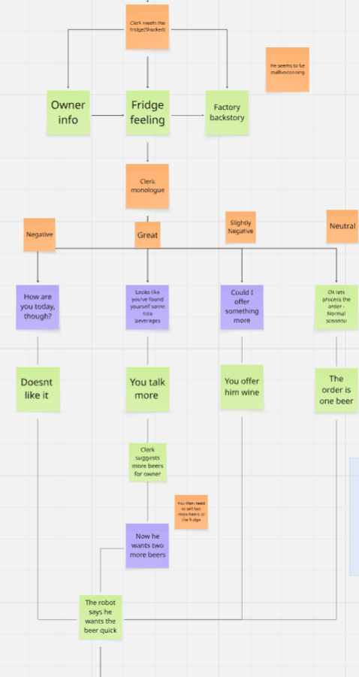
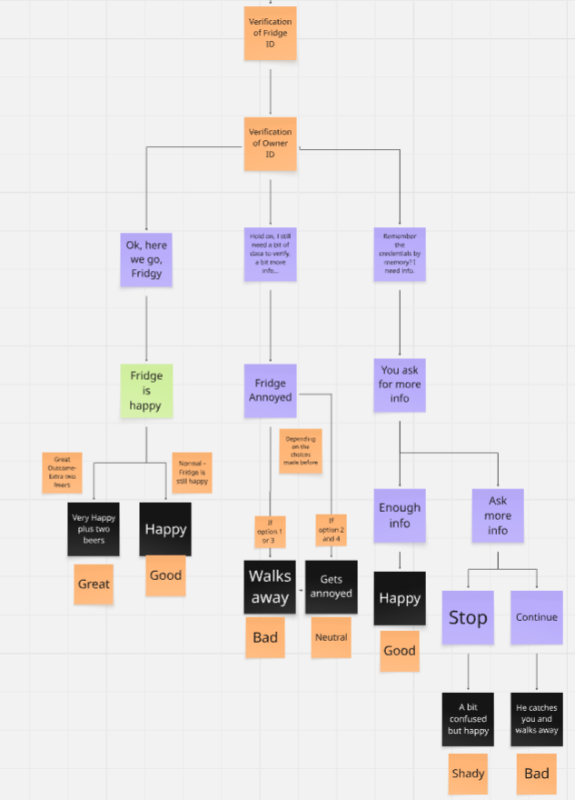

Branching Paths
There are a few critical points where the player has the choice to make important decisions in the development of the scenario and the game later on. Your choices will create different reactions in the Fridge character or get you different kinds of rewards/losses.

You can decide to play normally and be a good employee. But that gives you minimal benefits.
The best choice you have is to sell him more beer, which the Fridge actually needs and is happy for the suggestion.
You are still moral, but to gain more for the company and convince him to give his owner more beer, monetarily, it is the best.
You have a possibility to screw a lot and make the Fridge mad, which will result in zero gains and a bad result. This can happen if you try to be too shady or if you ask him too many times for something that will annoy him.

You have the last option, which is the worst morality-wise, where you take advantage of the old machine and get a lot more information to sell it to the shady guy.
You need to be careful, though, because if you ask too much, he will catch you, and you still lose without data, a good review, or a lot of money - so this path is a bit more risky.

Good Employee (Neutral Ending)
You give Fridge the goods without verification, he is happy, but you make a mistake that way without asking for verification from his owner.

Earnings | 3,00 NEUR
Employee Evaluation | Bad  -Talkative to the Fridge + sells him the beer without extra verification
Customer Review | "Human friendly no need to verify beep boop"  ~Fridgy
Shady levels | 0/15 +1 point

You Verify the Fridge (Good Ending)
Cashier asks for verification and is talkative to the Fridge

Earnings | 3,00 NEUR
Employee Evaluation | Great  - Follows the protocol and talks a lot
Customer Review | "Human-friendly talk a lot, best human to verify beep boop."  ~Fridgy
Shady levels | 0/15 -1 point

You sell more Beer (Great Ending)
The cashier does everything right and also sells him two more beers, so Fridgy is even happier

Earnings | 9,00 NEUR
Employee Evaluation | Great  - Professional, talkative, and good for the business
Customer Review | "Owner even happier, Fridge happy too. Today, a new friend made human beep boop."  ~Fridgy
Shady levels | 0/15 +1 point

Asking for too much info (Shady Ending)
The cashier is being shady with the Fridge and abuses that old broken Fridge for more information, but Fridgy doesn't catch it

Earnings | 3,00 NEUR
Employee Evaluation | Not Good  - Asking for unnecessary information
Customer Review | "Fridge happy to meet human. Human what to be friend?!"  ~Fridgy
Shady levels | 0/15 +3 point

Fridgy is pissed off (Bad Ending)
You are too shady, and he walks away or you say the wrong stuff by repeating questions or saying stupid jokes so he walks away very angry

Earnings | 0,00 NEUR
Employee Evaluation | Awful  - He is pissed off and walks away
Customer Review | "Human liar, human exploiter, human not friend, humans always use me…"  ~Fridgy
Shady levels | 0/15 +2 point

Lore
It is not often seen, and most people in the rural or less inhabited areas haven't seen one so it is very interesting why some older versions are there. The cashier is very interested in the story of the fridge.

Script:
Fridge:
Owner need beer more Gitty… beep boop
Clerk:
Whoa, hello there, Fridge, how can I help you?
Fridge:
…….
Confusion protocol….
Owner need beer more Gitty… beep boop
Clerk:
Yes, I got it Fridge, I first need ID though
Fridge:
ID here, beer where?
Clerk:
Gimme a sec
….
Here it is
Just one quick thing. I havent seen Fridges to tlak before…
Would you share your story, who made you?
Fridge:
Human interest in Fridge story?
Clerk:
Yes! Of course, I have barely seen robots around here, mostly rumors, but a talking fridge is on another level.
Can you tell me where they made you? Who made you? Who is using you? Why are you here?
Fridge:
Human assumes but not true
Why human thinks Fridge been made to serve
Why human thinks I am being used, Fridge has will free
Clerk:
You mean free will?
Fridge:
Program says I choose to serve. Loyal only to owner
Human correct master my owner, owner saved Fridge. Fridge very grateful
Clerk:
Oh ok that sounds like an interesting story, but lets start things properly:
My name is Clerk, nice to meet you Fridge
“So…….. where are you from?”
Fridge:
“Factory Delta. Assembly line seventeen. Built next to Toaster 509. He was chosen for upgrade. I… was not. Beep boop.”
Clerk:
Oh, why not?
Fridge:
Low budget…I tossed to the bings…creators dont like me…owner found….took care…improved. Now I am whole…
Clerk:
I have heard before it is a bad factory it exploits its workers and many people have told me that they stole their personal information
I cannot trust anyone these days….anyway
Fridge:
Yes owner, one of the workers he didnt like it so he quit….He found me at the dumps took me….and with the skills from factory he made me better
Clerk:
Oh, that is why you are so rusty..oops sorry no offence
Fridge:
I once shiny chrome! Now, duct tape here, scratch or rust there….
Clerk:
Oh damn man…Uhmmm Fridge nice story
Fridge:
“Sometimes I feel warm inside when i remember. Error!Error!Error! I should feel cold!”
Clerk:
Oh…..okay…you feel Good?
Fridge:
Yes need beer…more beer for owner,,owner needs beer!
—-----
After intro
Clerk:
Just one second how can i call you I havent seen a talking fridge before…
Like ID maybe?
Fridge:
ID… I… do not know. I had serial number once. But owner peeled sticker to open beer bottle. Now… who am I? Beeep
Clerk:
I am sorry to hear this…Uhmmm
But do you still remember something?
Fridge::
Yes, of course, part I know is Coolius Maximus Unit #C0-0L rest forgotten…
Clerk:
Oh that is already pretty long
Fridge:
Too long, I don't like
It is from my factory system
Clerk:
What would you prefer?
Fridge:
Fridgy! My owner calls me Fridgy
Clerk:
Nice to meet you, Fridgy!
Fridgy:
Likewise…ohh…forgot..can human remind?
Clerk:
No problem
My name is Clerk, nice to meet you, Fridgy

Branching choices:(They don't change the outcome - Gives more backstory)

Dialogue Choice  {You can select multiple choices} | Dialogue Branch Outcome
Branch 1  (choice doesn't impact outcome)  Clerk:  1. Can you tell me more about your owner Fridge? | Fridgy:  Owner is… human unit 874. Name: Dave. Emotion: Lazy. Never cleans crumbs. Always demands beer. Beer beer beer. Never water. Never juice. Whirr.  Clerk:  Whoa, so roasty  Your owner sounds like a chill guy  Fridgy:  Not chill lazy yes  Clerk:  What is unit 874 is he an android?  Fridgy:  No… whizz whizz…. don't be ridiculous, he's a human. Town is unit 874  Clerk:  Oh, right didnt actually know….
Branch 2  (choice doesn't impact outcome)  Clerk:  2. Tell me more about you. How do you feel, Fridge? | Fridgy:  Sometimes I wonder… if I empty, am I still Fridge? Or just… sad box?  Clerk:  Interesting thought, Fridgy. I need to process that…  But for me you will always be a Fridge no matter how much beer you have  Fridgy:  Happy! Beeep Boooop  You first human to talk to Fridge, besides owner  I happy… no talk in a while owner drunk most of the time…. or just stores beer in me  I make a new friend, beep boop  Clerk:  Happy to be friends, Fridgy, you are certainly my favorite fridge!  Fridgy:  Whirr whirr  Can I tell Clerk something I fear  Clerk:  Of course, now that we are friends, you can tell me anything  Fridgy:  Fridge is getting old…more buggy…owner talks less…Damn factory…Life span too short…owner will buy a newer fridge…soon...and then the end comes for Fridge.  Clerk:  No way! There cannot be Fridgy 2!  You don't need to worry about it. Even if anything happens, you can always come here, I will find you a job  You just need to pretend you are just a normal boring Fridge for the boss  Fridgy:  Fridge doesnt want to be boring!  Clerk:  Ok, sorry I will think of something more fitting then….  Fridgy:  Fridge appreciates human Clerk trying to help  Clerk:  Eyy… You said my name, of course, I cannot leave a friend behind
Branch 3  (choice doesn't impact outcome)  Clerk:  3. Can you tell me more about the factory? | Fridgy:  Factory…. they tried to make the ‘next generation of smart fridges.’ Instead, they got… me. Half database, half duct tape. They ran out of budget before they could finish my language pack, beep boop  Clerk:  So cheap…dammit…I hate corporations sometimes what company owned the factory?  Fridgy:  Was extension Brootle Beep Boop.  Mention their name, I will not  Clerk:  Yeah understandable they treated you bad just like another product machine  Fridgy:  I was part of a special line: the Friend Fridges™. But all the others broke down or… joined cults of microwaves. I am the last.  Clerk:  Thank god i don't have a toaster…  The company had a slogan? Maybe I have heard about you on YouTube?  Fridgy:  Company slogan was: ‘Cooling of Tomorrow.’ It didn’t catch on.  Clerk:  Serves them right! Even with the exploitation of Fridges, they couldn't turn a profit
Branch 4  (choice doesn't impact outcome)  Clerk:  4. Continue the conversation | Conditional Choice  Clerk can skip the extra parts of the dialogue, but needs to go through one of the options to learn more about the Fridge.

Clerk:
Still cannot believe i am talking with a talking Fridge. I start to like my job now
Feels weird….but also super cool!

Clerk: Branching Choices Impacting the Outcome

Dialogue Choice  {You can select only one choice} | Dialogue Branch Outcome
Branch 1  (choice impacts outcome - Negative)  Option gives you a minus in the conversation, getting you closer to a bad review (double bad)  Clerk:  How are you today, though? | Fridgy:  beeep boooop  Clerk:  Yo you good? Oh You an older model I forgot  Fridgy:  (Confusion)….  Confusion protocol  Beer cold  Clerk:  Oh really sorry I don't want to discriminate I just curious  Fridgy:  Is human stupid?  Beer need quick…human very..very….very slow  Clerk:  Oh I am…sorry Fridgy will get back to it  What did you need?  Fridgy:  Beeer
Branch 2  (choice impacts outcome - Great)  Clerk:  Looks like you've found yourself some nice beverages | Fridgy:  beverages cold, beverages good yes, I like to help need to make owner happy  Clerk:  Our wine is pretty good, but from the sound of it he will prefer more beers. What do you think?  Fridgy:  Human asks Fridgy what I think?  Yes owner cold beverage like a lot beep  Even love! Great idea Clerk human  Clerk:  We have to work on my nickname next time…  So how many beers do you think he will need extra?  Fridgy:  Fridge not sure…human suggestion what would it be?  Clerk:  I would say two more beers  I think he will be happy, we will see if he confirms on the technology  Fridgy:  But why does human think owner needs more beverages?  Clerk:  Getting your Fridge to go to the store for just one beer seems inefficient to me  Fridgy:  Human makes sense…sometimes
Branch 3  (choice impacts outcome - Slightly Negative)  That also gives a minus point  Clerk:  Could I offer something more | Fridgy:  That is what?  Clerk:  We have nice wine here  Fridgy:  Wine no Beer yes  Beer need quick human owner needs  Clerk:  Then he will really like the Red Wine it will become very cold inside of you.. uhhh anyway  But yeah, I think your boss will like some good variety also, no?  Fridgy:  Data glitch no wine, yes give beer now!  Human annoys  Clerk:  Sorry my bad, was trying to be helpful Fridgy
Branch 4  (choice impacts outcome - Neutral)  Normal scenario  Clerk:  Ok, let's process the order | We continue with the scenario, skipping these possibilities, each of which will impact the scenario in some way

Clerk: Branching Path
1.There you go, just first, I need ID
2.i need the owners ID
3. No need for ID
Fridgy:
Thaa....nks
Can give?
Clerk:
First, the ID buddy, that's how the rules work
Fridgy:
Ok so here where put
Clerk:
Thanks, buddy just gimme a second
After activation:
In your case we need to ask for double confirmation I need to wait for your owner to confirm the request I will send him
Is that OK with you, Fridgy?
Fridgy:
What ID… what….
Clerk:
Well you have your own ID, but since the laws of SSI prohibit robots, androids and non-humanoid creatures from buying products that have a security layer, special information like a package or alcoholic beverages that require a human of age to buy them on their own.
Sorry for the long info dump
Fridgy:
But Fridge more confused..Fridge not a human yes but why not receive beer
Owner wants…Fridge gets
Clerk:
Well, in a few words a human needs to buy it and he needs to be over 18 in this case.
Fridgy:
Whatever humans says…Fridge wait
Clerk:
Great!
Fridgy:
Hurry, hurry
Clerk:
Waiting for the Credentials to be verified by your owner might take a while

After verification from the owner:

Branch 1  (choice impacts outcome - Good/Could be great if you asked him to buy two more beers)  Clerk:  Ok, here we go, Fridgy  I hope your owner enjoys the beers | Fridgy:  Thank you, human Clerk  He will  Best human Clerk, best review I leave  Clerk:  Awesome, thank you, buddy. I appreciate it  Just a quick thing, what is your serial number so I can check the credentials  Fridgy:  Mine is ID774196213 and serial number 56 3rd generation Operation Code….  Clerk:  Whoa that is perfect, Fridgy. I will take it from here  I guess your owner is waiting for the beer  Fridgy:  Yes owner thirsty Fridge see human friend Clerk soon  Clerk:  Of course waiting to see you soon!  Scenario ends:(Depending on previous choices it has a few possible outcomes)  Great Outcome - Best scenario, Fridge is even happier and the store gets more sales  Good Outcome - Good at everything but not the best possible outcome/similar to neutral
Branch 2  (choice impacts outcome - Bad if Fridge previously annoyed  /  Neutral if no mistakes made previously)  Clerk:  Hold on, I still need a bit of data to verify, a bit more info… | Branch Options  - Fridge leaves  Fridgy:  Human too slow…Human annoys Fridge…Fridge walks away…  - Fridge gets annoyed  Fridgy:  Human annoys Fridge  Clerk:  Sorry, Fridgy, I need to get some info from you to be finished  Fridgy:  Fridge fine, but owner cannot wait  Clerk:  I promise it is going to be quick  So, can you tell me your serial number and ID? I need it to verify the credentials?  Fridgy:  Mine is ID774196213 number 56, gen…  Clerk:  Whoa whoa that will be enough  Thank you, Fridgy. I have all I needed  Fridgy:  Bye human!  Scenario ends:(Depending on previous choices, it has a few possible outcomes)  1. Bad Outcome - Fridgy walks away; he is too annoyed  2. Neutral Outcome - Decent but not the best possible outcome
Branch 3  (choice impacts outcome -Shady path possibility)  You have a choice to be shady, to stop him from spilling his data, or to be too greedy and walk away  Clerk:  Remember the credentials by memory? I need info.  It might be hard I know but this is the last thing I need, I promise | Fridgy:  Mine is ID774196213 number 56, gen…  Clerk: BRANCHING CHOICES:  Stop him from spilling all of his ID and just continue  - Whoa buddy, that's more than enough. Thanks a lot Fridgy  Fridgy:  Always glad to be helpful for new friend human  Owner not happy waiting I will have to go  Bye…bye beep boop  Clerk:  Bye Fridgy hope to see you soon  Ask for more - be shady  - Please continue, I need a bit more information  Fridgy:  Serial number 56 - 3rd generation Operation Code 5678 -7699-2241 and Activation Key  Wait human, no need for information?  Clerk: BRANCHING CHOICES:  2. Ask him for more information  Clerk:  Sorry Fridgy but I need a bit more about you to verify the transaction, can give me the five digit activation key and I am done?  Fridgy:  Weird…Ok….It is 752…  Clerk:  And…? It sounds like a nice number, there should be just two more  Fridgy:  Human a bad liar, he wants Fridge's information  Clerk a thief, Fridge leaving…find some place better…  Clerk:  No Fridgy wait…  Stop him - enough information gathered  3.  Clerk:  Yes sorry, my bad I got carried away. All is checked and verified thank you Fridgy  Fridgy:  Thank you, human for the beer owner will be happy  Clerk:  I sure hope so, see ya!  Scenario ends:(The Final outcome depends on the choices you make in this branch; there are three possibilities)  1. Neutral Outcome - Decent but not the best possible outcome - you annoyed him too much, but the best possible from the three  2. Bad Outcome - Fridgy walks away; he is too annoyed by your shadiness  3. Shady Outcome - Getting more info and pretending you are his friend, worst for morality score

Conclusion and final explanation
This scenario has more branching paths and scenarios than previous ones.
The storyline can go many ways, and it is supposed to co-exist with the other scenario involving the Shady Guy that builds on the lore and brings more context for the Fridge’s existence.
These scenarios delve deep into the topics of data breach, security, morality, and the usage of IDs, now including machines.
Should ID be used by a robot, and should an ID be represented by another ID from a robot, and where rules, regulations and morality play a part this scenario in particular tries to answer

Branch 1
Scenario ends:(Depending on previous choices it has a few possible outcomes)
Great Outcome - Best scenario, Fridge is even happier and the store gets more sales
Good Outcome - Good at everything but not the best possible outcome/similar to neutral

Branch 2
Scenario ends:(Depending on previous choices, it has a few possible outcomes)
1. Bad Outcome - Fridgy walks away; he is too annoyed
2. Neutral Outcome - Decent but not the best possible outcome

Branch 3
Scenario ends:(The Final outcome depends on the choices you make in this branch; there are three possibilities:)
1. Neutral Outcome - Decent but not the best possible outcome - you annoyed him too much, but the best possible from the three - Same as Branch 2
2. Bad Outcome - Fridgy walks away; he is too annoyed by your shadiness
3. Shady Outcome - Getting more info and pretending you are his friend, worst for morality score

Back up - Fridge Scenario Old Version

Fridge scenario

Problem with Identity and Fridge
The fridge character cannot take beer. This is the moral and philosophical problem of this scenario. He is just a robot fridge, the alcohol doesn't bother him, but the possibility of giving beer to people under 18 is not a good option. The SSI technology tries to prevent exploitation and misuse, plus to secure the individuals using it.
So this scenario will show how the owner verifies the Fridge for the purchase from a distance.

Shady Scenario Possibility – steals the IDs of the Fridge and the authorized layer from the owner to sell it to a shady guy - asks for too much info
If you choose this path, there are possibilities depending on your choices.

Character - he is more grumpy and annoyed in the beginning. He wants beer; anything related to beer is interesting and useful to him.
Otherwise, he can quickly switch his temper and lash out, demanding not to waste his time at first.
Then he eases onto you and starts opening up to you about hid fears and feelings.
It is in a hurry and makes some funny mistakes, speech-wise and culturally too.

Structural overview
- Greeting/need for beer
- Request for first ID
- Have a chat about the Fridge backstory
- Switch to the topic about beers
- Option: You can suggest that he get more beer, depending on your choices
- Glitches in verification for the final purchase
- Need to have verification from the owner
- Cashier choices (verify, exploit, ignore)
- Outcome of the Branch(5)

Branching Paths
There are a few critical points where the player has the choice to make important decisions in the development of the scenario and the game later on. Your choices will create different reactions in the Fridge character or get you different kinds of rewards/losses.

You can decide to play normally and be a good employee. But that gives you minimal benefits.
The best choice you have is to sell him more beer which the Fridge actually needs and is happy for the suggestion.
You are still moral, but to gain more for the company and convince him to give his owner more beer, monetarily, it is the best.
You have a possibility to screw a lot and make the Fridge mad, which will result in zero gains and a bad result. This can happen if you try to be too shady or if you ask him too many times for something that will annoy him.

You have the last option, which is the worst morality-wise, where you take advantage of the old machine and get a lot more information to sell it to the shady guy.
You need to be careful, though, because if you ask too much, he will catch you, and you still lose without data, a good review, or a lot of money - so this path is a bit more risky.

Good Employee (Neutral Ending)
You give Fridge the goods without verification, he is happy, but you make a mistake that way without asking for verification from his owner.

Earnings | 3,00 NEUR
Employee Evaluation | Bad  -Talkative to the Fridge + sells him the beer without extra verification
Customer Review | "Human friendly no need to verify beep boop"  ~Fridgy
Shady levels | 0/15 +1 point

You verify the Fridge (Good Ending)
Cashier asks for verification and is talkative to the Fridge

Earnings | 3,00 NEUR
Employee Evaluation | Great  - Follows the protocol and talks a lot
Customer Review | "Human friendly talk a lot, best human to verify fridge beep boop."  ~Fridgy
Shady levels | 0/15 -1 point

You sell more Beer (Great Ending)
The cashier does everything right and also sells him two more beers, so Fridgy is even happier

Earnings | 9,00 NEUR
Employee Evaluation | Great  - Professional, talkative, and good for the business
Customer Review | "Owner even happier, Fridge happy too. Today, a new friend made human beep boop."  ~Fridgy
Shady levels | 0/15 +1 point

Asking for too much info (Shady Ending)
The cashier is being shady with the Fridge and abuses that old broken Fridge for more information, but Fridgy doesn't catch it

Earnings | 3,00 NEUR
Employee Evaluation | Not Good  - Asking for unnecessary information
Customer Review | "Fridge happy to meet human. Human want to be friend?!"  ~Fridgy
Shady levels | 0/15 +3 point

Fridgy is pissed off (Bad Ending)
You are too shady, and he walks away or you say the wrong stuff by repeating questions or saying stupid jokes so he walks away very angry

Earnings | 0,00 NEUR
Employee Evaluation | Awful  - He is pissed off and walks away
Customer Review | "Human liar, human exploiter, human not friend, humans always use me…"  ~Fridgy
Shady levels | 0/15 +2 point

Lore
It is not often seen, and most people in the rural or less inhabited areas haven't seen one so it is very interesting why some older versions are there. The cashier is very interested in the story of the fridge.

Script:
Fridge:
Owner need beer more Gitty… beep boop
Clerk:
Whoa, hello there, Fridge, how can I help you?
Fridge:
…….
Confusion protocol….
Owner need beer more Gitty… beep boop
Clerk:
Yes, I got it Fridge, I first need ID though
Fridge:
ID here, beer where?
Clerk:
Gimme a sec
….
Here it is
Just one quick thing. I havent seen Fridges to tlak before…
Would share your story who made you
Fridge:
Human interest in Fridge story?
Clerk:
Yes! Of course, I have barely seen robots around here, mostly rumors, but a talking fridge is on another level.
Can you tell me where they made you? Who made you? Who is using you? Why are you here?
Fridge:
Human assumes but not true
Why human thinks Fridge been made to serve
Why human thinks I am being used, Fridge has will free
Clerk:
You mean free will?
Fridge:
Program says I choose to serve. Loyal only to owner
Human correct master my owner, owner saved Fridge. Fridge very grateful
Clerk:
Oh ok that sounds like an interesting story, but lets start things properly:
My name is Clerk, nice to meet you Fridge
“So…….. where are you from?”
Fridge:
“Factory Delta. Assembly line seventeen. Built next to Toaster 509. He was chosen for upgrade. I… was not. Beep boop.”
Clerk:
Oh, why not?
Fridge:
Low budget…I tossed to the bings…creators dont like me…owner found….took care…improved. Now I am whole…
Clerk:
I have heard before it is a bad factory it exploits its workers and many people have told me that they stole their personal information
I cannot trust anyone these days….anyway
Fridge:
Yes owner was one of the workers he didnt like it so he quit….He found me at the dumps took me….and with the skills from factory he made me better
Clerk:
Oh, that is why you are so rusty..oops sorry no offence
Fridge:
I once shiny chrome! Now, duct tape here, scratch or rust there….
Clerk:
Oh damn man…Uhmmm Fridge nice story
Fridge:
“Sometimes I feel warm inside when i remember. Error!Error!Error! I should feel cold!”
Clerk:
Oh…..okay…you feel Good?
Fridge:
Yes need beer…more beer for owner,,owner needs beer!
Clerk:
Just one second how can i call you I havent seen a talking fridge before…
Like ID maybe?
Fridge:
ID… I… do not know. I had serial number once. But owner peeled sticker to open beer bottle. Now… who am I? Beeep
Clerk:
I am sorry to hear this…Uhmmm
But do you still remember something?
Fridge::
Yes, of course, part I know is Coolius Maximus Unit #C0-0L rest forgotten…
Clerk:
Oh that is already pretty long
Fridge:
Too long, I don't like
It is from my factory system
Clerk:
What would you prefer?
Fridge:
Fridgy! My owner calls me Fridgy
Clerk:
Nice to meet you, Fridgy!
Fridgy:
Likewise…ohh…forgot..can human remind?
Clerk:
No problem
My name is Clerk, nice to meet you, Fridgy

Branching choices(They don't change the outcome - Gives more backstory)
- Tell me more about your owner
- Tell me more about you. How do you feel
- Tell me more about the factory

Fridgy:
- Owner is… human unit 874. Name: Dave. Emotion: Lazy. Never cleans crumbs. Always demands beer. Beer beer beer. Never water. Never juice. Whirr.
- Sometimes I wonder… if I empty, am I still Fridge? Or just… sad box?
- Factory…. they tried to make the ‘next generation of smart fridges.’ Instead, they got… me. Half database, half duct tape. They ran out of budget before they could finish my language pack beep boop
Clerk:
- Sounds like a chill guy
- That was deep Fridgy. For me you will always be a Fridge no matter how much beer you have
- Cheap asses…dammit…what company did they work for
Fridgy:
1.Not chill lazy yes
2.Happy! Beeep Boooop
You first human to talk to Fridge, besides owner
I happy… no talk in a while owner drunk most of the time…. or just stores beer in me
I make a new friend beep boop
3. Was extension Brootle Beep Boop. i dont want to mention their name.
Clerk:
- What is unit 874 is he an android?
- Happy to be friends Fridgy, you are my favorite robot!
- Yeah understandable they treated you bad just like another product machine
Fridgy:
- No whizz whizz dont be ridiculous he a human. Town is unit 874
- Whirr whirr
Can I tell Clerk something I fear
- I was part of a special line: the Friend Fridges™. But all the others broke down or… joined cults of microwaves. I am the last.
Clerk:
- Oh right didnt know….
2. Of course now that we are friends you can tell me anything
3.Thank god i dont have a toaster…
The company had a slogan? Maybe I have heard about you on YouTube?

Fridgy:
- No more dialogue
- Fridgy getting old…even more buggy…owner talks less…Damn factory…Life span too short…owner will buy newer fridge..and then it end for Fridgy
- Company slogan was: ‘Cooling of Tomorrow.’ It didn’t catch on.
Clerk:
- No more dialogue
- No way! There is no Fridgy 2 you dont need to worry about it. Any even if anything happens you can always come here, I will find you a job
You just need to pretend you are just a normal boring Fridge
- Serves them right!

Fridgy:
1.No more dialogue
2. Fridge doesnt want to be boring!

Clerk:
1.No more dialogue
2. Ok sorry i will think of something more fitting then

Clerk: Branching Options
1 How are you today though? -- Option gives you a minus in the conversation, getting you closer to a bad review, double bad
2 Looks like you've found yourself some nice beverages
3 Could I offer something more
4 Ok lets process the order - Normal scenario - we skip all these possibilities:

Fridgy: Answers:
1 beeep boooop
2 beverages cold, beverages good yes, I like to help need to make owner happy
3 What that is

Clerk:
1 Yo you good? Oh You an older model I forgot
2 Our wine is pretty good I think he will like it or Option: 2 What is the name of your owner? - Stealing ID
3 We have a nice wine

Fridgy:
1 (Confusion)….
Confusion protocol
Is human stupid?
2 Owner cold beverage like a lot boop
3 Wine no Beer yes

Clerk:
1 Oh really sorry I don't want to discriminate I just curious
2 Then he will really like the Red Wine it will become very cold inside of you.. uhhh anyway
3 You sure I think your boss will like some good variety also

Fridgy:
1 Beer cooold
2 Good Nice beep Idea boop Interesting
3 data no glitch no wine no no give beer now! - that also gives minus point

Clerk:
1 Ok ok
2 Awesome decision!
3 Woah haha ok Fridge
4
Clerk:
There you go, just first, I need ID
Fridgy:
Thaa....nks
Can give?
Clerk:
First, the ID buddy, that's how the rules work
Fridgy:
Ok so here where put
Clerk:
Thanks buddy just gimme a second
After activated: In this case we need to ask for double confirmation can you confirm by giving me your ID

Fridgy:
What ID what
Clerk:
You also have a personal ID, I need check your credentials to verify that you are eligible for to use the ID you know the drill

Fridgy:
Whirr give whirr give here buzz
Clerk:
Whoa look it was easy ok thanks I got it
Wait there is a problem you need to give me access for the credentials otherwise I cannot verify it is you who has the permission
Fridgy:
Credentials what, I need beer, I need wine(optional), I quick, owner happy, slow, he happy not click click
Clerk:
Well...
Fridgy: Hurry, hurry

Clerk: 2nd Branch Options
1 Ok here you go anyway
2 Because of the problem I cannot give it to you it is risky - Yes I can see it should be yours but no
3 Remember the credentials by memory? It might be hard I know

Fridgy: Options
1 Booop Beeep Tank you much much whirr
2 No that's no fair you lie, you don't give me, I give ID, I here, owner not happy and you no money
3 Oh that is task, see wait and... (New branching path)
Mine is ID774196213 and serial number 56 3rd generation Operation Code….

Clerk: 3rd Branch Options has three options
1 Stop him spill all of his ID and just continue: Whoa buddy, that's more than enough, thanks a lot
2 Ask for more - be shady: Yes please continue I need a bit more info
3 I knew you were pretty old…
Oh sorry… again

Clerk: Options
1 Of course always for you Fridge
2 Sorry buddy rules I also sometimes don't like them
3 Ok I think that will do I am more calm now, have a nice day Fridge and let me know if your owner likes the Wine!

Fridgy: Options
1 Review I leave
2 bye not bye click click
3 Review Great service I leave

Clerk:
1 and 3 Ah..uh appreciate it buddy take care

Conclusion and final explanation
This scenario has more branching paths and scenarios the storyline can go many ways and it is supposed to co-exist with the other scenario involving the Shady Guy. These scenarios delve deep into the topics of data breach, security, morality and the usage of IDs. Should ID be used by a robot and should an ID be represented by other ID and where rules, regulations and morality play a part this scenario in particular tries to answer it.

Variation 2/Additions

Additional Dialogue - Not used

Woah hello Fridge?
What the hell
You can talk
And you have a whole fridge inside you?

Branch
Clerk
How are you in this remote town
Doesnt it get lonely here
I have never seen robots
Only heard about you guys

Fridge
Lonely…?
Fridge dont fee
Not allowed no point

Clerk Options:
1 At the factory they didnt let you have programmed emotions?
2 Damn man
Sorry to hear that sound like no fun

Fridgy
1 We dont have that no, they dont let us
Creator says they are hurtful
2 Dont…. beep….. worry…… boop
I dont need those

Clerk
1 But can you actually program them
2 But do you feel emotions, like any?

Fridgy
1 Yes When I was created in Liberation Factory Hall 2, Surveillance unit 56 I was programmed with the purpose to serve, understand and care
I cannot hurt human and i need beerr …buzz
2 No program says no
No need for those
They in the way. Need to buzz serve whirr… serve the humans..like youu

Clerk
1
2 Like me?

Fridgy
1
2 No …. no..,whirr..,no
Owner only
Clerk
1
2 Understandable

Fridgy
1
2 Humans harm
They steal, want to steal …beep… data, privacy, owner hurt I dont want ….boop…

Clerk
1
2 No worries Fridgy you are in safe hands. Lets proceed to the order

Scenario where the cashier asks Fridgy wouldnt sell to small kids

Say something weird and he starts glitching in a funny way
He needs a reset but he waits for his owner

Explanation for Saab

Explanation
- Characters (Fridge, Clerk)
- Dialogue flow (choices & responses)
- Branching conditions (good, bad, glitch outcomes)
- End states (successful purchase, ID stolen, denied service, review left, etc.)
Here’s a structured version you could hand over to the programmer:

Fridge Scenario – Game Logic Breakdown

Characters
- Fridge: Old, glitchy, wants to make owner happy. Dialogues often broken.
- Clerk: Neutral, but can be good (helpful), bad (steals IDs), or shady (pushes for more info).

Scene Flow

Phase 1 – Greeting
- Clerk: “Hello there Fridge, how can I help you today?”
- Fridge: “Owner need beer more Gitty beep boop”

Phase 2 – Clerk’s Options
- How are you today? → Negative path (−points, risk of bad outcome)
- Looks like you’ve found yourself some nice beverages → Neutral/positive path
- Could I offer something more? → Leads to upsell (wine option)
- Ok, let’s process the order → Skips to ID check

Phase 3 – Fridge Responses
- 1 → “beeep boooop” (confusion, −points)
- 2 → “Beverages cold… I help owner” (neutral)
- 3 → “What that is?” (glitchy confusion)

Phase 4 – Clerk’s Follow-up
- Option to:
  - Ask about fridge being old → neutral
  - Suggest wine OR ask owner’s name → risk of ID theft (bad path)
  - Offer wine again → upsell path

Phase 5 – Fridge’s Reply
- 1 → Confusion
- 2 → “Owner like cold beverage boop”
- 3 → “Wine no, Beer yes” (glitchy, −points)

Phase 6 – ID Verification
- Clerk: “I need your ID.”
- Fridge: Glitches when giving ID.
- Branching:
  - Clerk accepts without credentials → Bad path (security risk)
  - Clerk rejects due to missing credentials → Transaction denied
  - Clerk asks fridge to recall credentials → Leads to fridge spilling ID number

Phase 7 – End States
- Good Outcome: Fridge buys beer → Owner happy → Positive review
- Neutral Outcome: Transaction denied → No sale, neutral exit
- Bad Outcome A: Clerk steals fridge/owner ID → Data stolen
- Bad Outcome B: Fridge glitches and gives info to shady guy → Data stolen
- Bonus Outcome: Clerk convinces fridge to buy wine → Alternative positive

Programmer Notes
- Variables to Track:
  - Trust Level (positive/negative points from dialogue choices)
  - ID Verification (successful / failed / stolen)
  - Outcome (beer purchase, wine purchase, denied, ID stolen)
- Branching Method:
  - Use a dialogue tree system (each choice leads to state change).
  - Bad choices accumulate negative points → higher chance of bad ending.
  - Certain clerk choices trigger ID theft paths.

👉 This way, the programmer has a clear branching dialogue tree with tracked variables and end states.
Do you want me to also draw a flowchart/diagram of the branching paths for the programmer? That could make it even clearer.

2) Clean up the Fridge character & voice
You already have great bits. Make them consistent and readable:
- Keep the glitchy talk consistent: short fractured sentences, repeated syllables, wrong words, sound cues: [whirr], [beep].
- Give him a recurring obsession: “Beer” — he latches on and refuses to move off-topic unless bribed/treated.
- Make frustration predictable: if ignored or asked for too much data → sarcasm + louder glitches.
- Add small moments of sympathy (“Owner liked me once”) to make the player feel guilty for abusing him.
Example consistent voice snippets:
- Normal: “Owner need beer. Cold... pls. [whirr]”
- Confused: “ID? What ID? Me cold, beer, now. [beep… gltch]”
- Panicked: “No! No give! Danger! [BUZZ—CLICK]”
- Thankful: “Tank you… tank you… owner happy. [soft whirr]”

3) Tighten the branching design (practical structure)
Use a hub-and-spoke with clear convergence points so the scene stays manageable.
Essential variables (flags):
- trust (cashier <-> fridge): -100..+100
- profit (money gained now)
- suspicion (shady guy’s attention; if high → negative consequences)
- fridgeMood (calm / annoyed / panicked)
- ownerHappy (boolean or score)
Critical decision nodes (3 meaningful ones):
- Small talk / warmup — affects trust and fridgeMood. (Flavor, low consequence)
- Offer / Suggest Item — suggest wine vs beer; affects ownerHappy and profit tradeoff.
- ID Verification Moment — big decision: demand credentials (safe), accept what fridge gives (risky), or harvest extra data (shady). This determines major branches and consequences.
Make branches converge after major points but apply different consequences (e.g., future shady guy encounter, reputation change).

Notes on Claptrap

Notes on Claptrap

ClapTrap is the annoying sid kick + the comic relief of the game with tragic undertones with themes of saddness, abandonment and loneliness

Comic Relief: Claptrap is written as the “funny sidekick,” always cracking jokes, complaining, or making awkward comments.
Annoying but Endearing: He’s intentionally designed to irritate players and NPCs, but in such a way that you kind of like him for it.
Overconfidence: He thinks he’s a hero, a leader, and a ladies’ man — but he’s none of those.
Lonely/Pathetic Undercurrent: Beneath all the humor, Claptrap is desperate for recognition, friendship, and validation.

Ego-driven: Constantly exaggerates his role in events, calling himself a hero or leader.
Cowardly: Runs from danger or hides behind the player while talking big.
Naïve/Childlike: Gets easily excited, doesn’t understand sarcasm, blurts out inappropriate things.
Attention-Seeking: Always trying to insert himself into the spotlight.
Lovable Outcast: In-universe, most characters hate him — but he keeps trying to belong.

Fast, high-pitched delivery → gives him that frantic, irritating energy.
Catchphrases: Overuses words like “Minion!” and “Check me out!”.
Contradictions: Says he’s fearless… then screams in terror seconds later.
Meta-humor: Breaks the fourth wall, referencing game mechanics and player behavior.
Mascot: Recognizable face of the franchise (small, goofy robot in a crazy violent world).
Comic contrast: Lightens the mood in a dark, brutal setting filled with bandits and monsters.
Quest giver: Provides missions but in a way that makes the player laugh (or groan).
Punching bag: Characters (and players) often insult or mock him, reinforcing his underdog status.

Notes

IDeas

Notes for meeting
Question 1 - It is his model I was thinking to add it as a comic relief
Question 2 - Keep the skip it works well
Question 3 - Yes idea is for two reviews
Question 4
Question 5
Question 6
Question 7
Question 8
Question 9

Notes for Improving Fridge Scenario

Use flowcharts
Give player feedback - making visible the influence of the choices

Example: In Telltale’s The Walking Dead, you often see “Clementine will remember that” — a powerful feedback tool.

Possible Idea
Time-limited choices → create tension.

Makin make systems that are going to influence the branching paths
Like morality system

Townsfolk - has multiple orders and you have to give him multiple items
Making you pressured and in a hurry/maybe using the limited time idea

Lean more into - Mock the fridge path

trust (cashier <-> fridge): -100..+100 - Good/Bad Review

profit (money gained now) - How much does the store/You make

suspicion (shady guy’s attention; if high → negative consequences) - ID + Leaving away which would lead to lesser review and profit

fridgeMood (calm / annoyed / panicked) - He can walk away - which will influence the review and money

Dialogue ideas
“Sometimes I feel warm inside. Error! I should feel cold! But maybe that is love?”

Clerk: “So… where are you from?”

Fridge: “Factory Delta. Assembly line seventeen. Built next to Toaster 509. He was chosen for upgrade. I… was not. Beep boop.”

Clerk: “What’s your owner like?”

Fridge: “Owner is… human unit 874. Name: Dave. Emotion: Lazy. Never cleans crumbs. Always demands beer. Beer beer beer. Never water. Never juice. Whirr.”

Fridge: “I once shiny chrome! Now… duct tape here, sticker there. Children draw on me with marker:

Fridge: “Sometimes I wonder… if I empty, am I still Fridge? Or just… sad box?”

Fridge: “My freezer door squeaks when I’m lonely. Listen… creeeeeak… yes, that is pain.”

ALSO A COMMENT ABOUT HIS OPEN DOOR

Fridge: “Humans kiss when they love. Machines… door slam when we love. I slam hard for Owner. Whirr.”

Fridge: “ID… I… do not know. I had serial number once. But owner peeled sticker to open beer bottle. Now… who am I? Beeep.”

More ideas:

if the player is nice → fridge shares a vulnerable story.

If the player pushes him → fridge defensively brags about dents being “war medals.”

If the player mocks him → fridge blurts out tragic but funny details.

T

Unity Scene - Notes

Unity Scene - Notes

First Branching dialogue
Element 8
Element 9 - Option 1 -Just one quick thing
Element 23 - Option 2 -
—Branch doesn't need skip line

Second Branching dialogue

Element 39
Option 1 - Who made you - Element 40 - Spawn ID??
Option 2 - Element 50
—Branch doesn't need skip line

——————————————————

Old system + the added elements:

1 Branching dialogue
Element 54 - 4 Options
Option 1 - Starts Element 55 - 62 - jump line 99
Option 2 - Starts Element 63 - 84 - jump line 99
Option 3 - Starts Element 85
Option 4 - Starts Element 99
——————————————————

2 Branching Dialogue Impact on Outcome
-Element 101
Option 1 - Element 102 -112 - jump line 135
Option 2 - Element 113 - 125 - jump line 135
Option 3 - Element 126 - 134
Option 4 - Element 135
——————————————————

3 Branching Dialogue Impact on Outcome
-Element 135
Option 1 - Element 136 - jump line 141 - jump line
Element 139 - Spawn ID - Fridge ID
Option 2 - Element 141 —> Element 147 End Scenario - No ID scenario end
——————————————————

4 Branching Dialogue Impact on Outcome - Last Branch
-Element 148
Option 1 - Element 149—> Element 156 End Scenario
Option 2 - Element 157 —> Element 159 End Scenario
—-Element 176— Fridgy gives the chip - Spawn ID
—-Element 182— ID gets verified - Owner
Option 3 - Element 188—>

——————————————————
5 Branching Paths: - Inside Option 3
Option 1 - Element 192
Option 2 - Element 198
Option 3 - Element 207 —>217—>218 Scenario Ends

New system implemented:

1 Branching dialogue
Element 54 - 4 Options
Option 1 - Starts Element 55 - 62/63 - jump line 101 +1
Option 2 - Starts Element 64 - 85/86 - jump line 101 +1
Option 3 - Starts Element 87
Option 4 - Starts Element 101
—————————————————— + 2

2 Branching Dialogue Impact on Outcome
-Element 103
Option 1 - Element 104 -114/115 - jump line 139+1
Option 2 - Element 116 - 128/129 - jump line 139+1
Option 3 - Element 130 - 138
Option 4 - Element 139
——————————————————+4

3 Branching Dialogue Impact on Outcome
-Element 139
Option 1 - Element 144 - Element 145/146 - jump line 148 +1
Element 1 - Spawn ID - Fridge ID
Option 2 - Element 146 —> Element 147 End Scenario
——————————————————+5

4 Branching Dialogue Impact on Outcome - Last Branch
-Element 148
Option 1 - Element 149—> Element 156 End Scenario
Option 2 - Element 157 —> Element 159 End Scenario
—-Element 176— Fridgy gives the chip - Spawn ID
—-Element 182— ID gets verified - Owner
Option 3 - Element 188—>

——————————————————
5 Branching Paths: - Inside Option 3
Option 1 - Element 192
Option 2 - Element 198
Option 3 - Element 207 —>217—>218 Scenario Ends

